The Seventh Annual Meeting of the Magna Masters Association was held at the The Royal Air Force Club, 128 Piccadilly, London W1J 7PY on 7 November, 2022 at 6pm
In attendance: Fiona Adler, Tony Alston, Nicholas Bence-Trower, Stephen Bernhard, Nic Birtles, Patrick Chapman, Michael Cooper, John Hitchins, Ian Locks, Ian McIntyre, Debby Ounsted, AVM Patrick O’Reilly (Chairman), Jeremy Randall, Barrie Stewart, Michael Godbee, Richard Herbert, Martin Miles, Tony Watson

AGENDA
- Welcome by Chairman: In his welcome the Chairman paid tribute to David Illingworth, our financial examiner and Richard Walker Arnott, husband of Debby Ounsted.
- Minutes of Sixth Annual General Meeting - 8 November 2021 were approved nem con.
- Apologies for absence. Neville Chamberlain; Kathleen Duncan; Edward Hutton; Simon Archer; Sir Roger Vickers; Nick Andrews; Geoff Lewis; Chris Ford; Rowland Hughes, John Shonfeld,
- To receive the Chairman’s report
In his report the chairman recalled the main events of the past year and expressed sincere thanks to the organisers of all the events.
2021
  - Our first live post lockdown outing was a walk around the Roman walls of the city led by Richard Herbert followed by lunch at Cutlers’ Hall
  - In the autumn of last year we were invited by our President, Sir Alan Yarrow to dine at Fishmongers’ Hall, one of the crown jewels of the City Livery Halls. A delightful evening. Sadly Sir Alan fell victim to Covid but Sheriff elect Andrew Marsden stepped in to do the welcome with wit and aplomb.
  - Slightly improbably we decided also to go ahead with our February Gala Dinner, kindly hosted by Tony Watson at Leathersellers’ Hall. Numbers at both events were slightly down on our previous expectations but much enjoyed nonetheless.
2022
29 March - Evening with the Magic Circle - excellent evening albeit falling rather short of expectations on attendance
30 May- 2 June - Visit to Loire wine growing area organised by Nic Birtles and Jeremy Randall (fully subscribed and a huge success which had encouraged us to look to the future with similarly adventurous ideas.) The Chairman thanked Nic Birtles for all his organisation and attention to detail and Jeremy Randall for his inspiration and support.
29 June - Dinner Lincoln’s Inn - Tony Watson. This event was capped at 20 to include Consorts and included a tour of the Great Hall and archives.
5 September - Open Committee: thank you to the 17 members who attended
3 October - Visit to WWII operations bunker at Uxbridge organised by Chris Ford and was a great success, much enjoyed by all who attended

7 November - AGM, wine tasting and dinner, RAF Club, Piccadilly: we have not succeeded in finding someone to take over the organisation of the wine tasting from Rass but we had found six of us willing to share the load of organising the wine. Thank you to them.

Upcoming events:
2023
8 February Eighth Gala Dinner at Apothecaries’ Hall hosted by John Moore-Gillon
6-8 June Visit to Lake District Stephen Bernhard and Neville Chamberlain

There was of course an open Invitation for offers to organise events in the coming year or in the future for which we had a number of interesting offers including
Visit to lake district organised by Stephen Bernhard and Neville Chamberlain plus VIP entrance to two nuclear power stations in that area. Visit to DP World London Gateway and adjoining farm (Ian Frood) tba (July) Other offers tba: Sabrage evening at Oriental Club Bob Morrow; dinner in the Long Room at Lords Tony Watson and planned for 2024 a trip to Portugal for wine tasting and a trip on the Duero on which Nic Birtles spoke briefly.

- To receive and adopt the Financial Report and Accounts for 2021-22
Martin Miles spoke briefly about the accounts he presented to the meeting which showed a big surplus in 2020/2021, in which there was no gala dinner, compared with 2021/2022 in which there were two. The year therefore showed a modest deficit which, the Chairman said, was fully justified to assist the Association restart its social programme. The accounts were approved unanimously by show of hands.
- Election of Officers for the coming year
Chairman: (Current holder Air Marshal Patrick O’Reilly) agreed unanimously.
Vice Chairman: (Current holder Jeremy Randall as immediate past chairman. One nomination had been received: see notes from Open committee 5 Sept 22)
The nomination from the Open Committee was for Ian McIntyre, MagnaMaster Tallow Chandler. Proposed by Richard Herbert and seconded by Graeme Groom. Carried unanimously.
All the additional officers were approved unanimously by show of hands:
Hon. Treasurer: Martin Miles, Actuaries.
Hon. Secretary: Ian Locks, Stationers and Newspaper Makers
Hon. Membership Secretary: Michael Godbee, Tax Advisors
Chairman Events Committee: Nic Birtles, Information Technologists
- Election of Financial Examiner The Chairman said this positioned had been efficiently occupied since MMA’s inception by David Illingworth who sadly died during the year after a long and brave fight against cancer. Nic Birtles, Past Master WCo Information Technologists was co-opted after David’s death and was willing to stand. Proposed by Martin Miles and approved unanimously.
- Other business. Two other items were introduced by the Chairman
- inclusion of consorts in AGM and dinner: TheChairman said he would like to get an idea of how many might like come to the dinner after the AGM. In discussion it was felt Consorts might be invited to remain in a separate room during the meeting and then to join in the wine tasting and dinner afterwards.
- terms of office The Chairman said it had been suggested five years was overlong for the post of Chairman given the age of the membership. After discussion, albeit no vote was taken, the Chairman said he sensed members felt that three years should probably be taken as the general view. This could be a guide.
- Duero June 2024 - Nic Birtles outlined a trip of three days and four nights in first week from 3 June 2024 with a price tag between £1300-£1500. He would be looking for 15 couples. Less than 12 was not economic. Considerable support was shown.
- The meeting was followed by a wine tasting at 7.00pm (led by Jeremy Randall with wine provided by Past Masters Randall, O’Reilly, Birtles, Bernhard, McIntyre, Miles and Locks, and Supper at 8.20pm. The event concluded at 10.00pm.
Ian Locks, Hon. Secretary
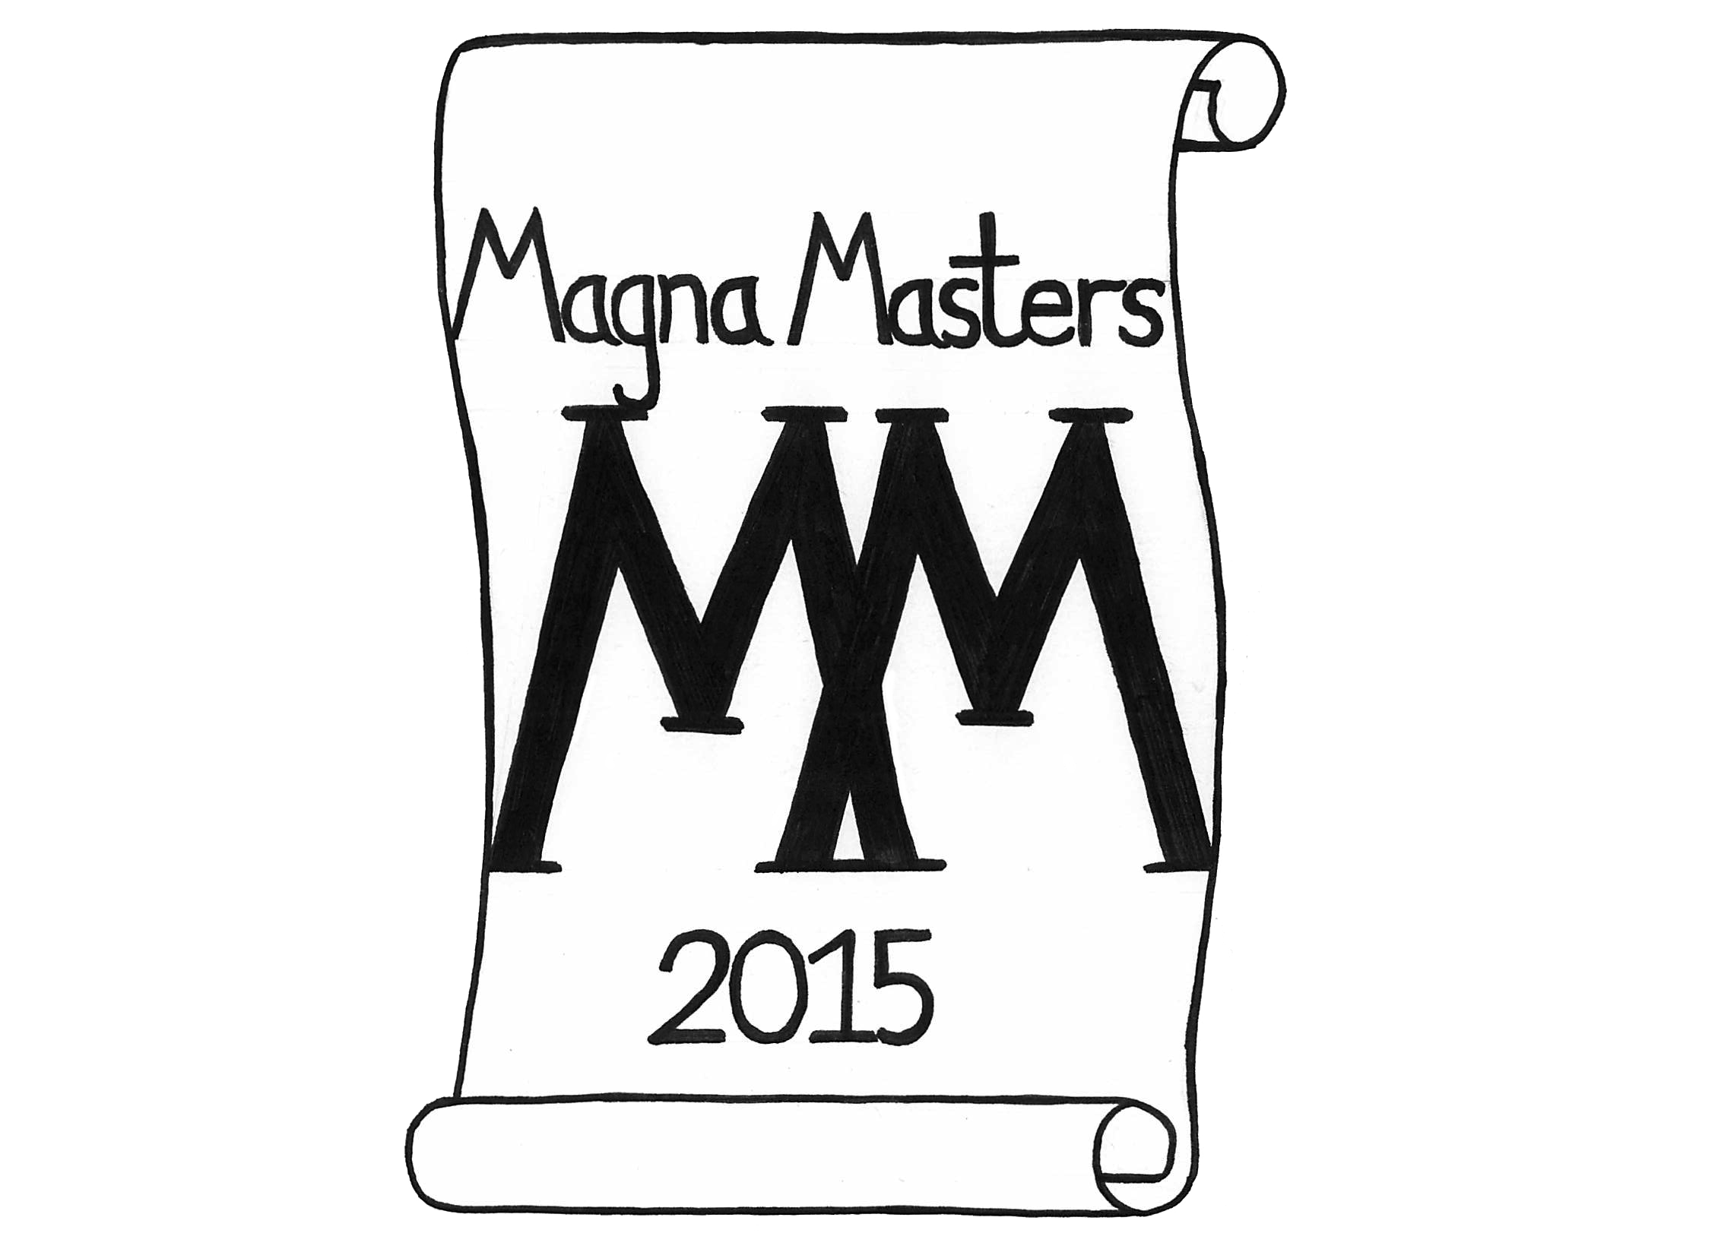
Minutes of AGM 8 Nov 2021

The sixth Annual Meeting of the Magna Masters Association was held a the RAF Club, Piccadilly, on 8 November 2021 commencing at 18.00

Recorded attending were: Nic Birtles, Chris Ford, Mark Henderson, Martin Miles,Tony Alston, Michael Cooper, Rowland Hughes, Nick Andrews, Ian Locks, Jim Conybeare, Andrew Marsden, Derek Woods, Jeremy Randall, Roger North, Debby Ounsted, Richard Herbert, Kevin Moore, John Hitchins, Allan Cheesman, Stephen Bernhard, Terry Last, Patrick O’Reilly, Patrick Chapman, Ian Mcintyre (24)

- Welcome by Chairman
Welcome to the Sixth Annual General Meeting of the Magna Masters Association after what has been varied year with Zoom playing an important role in the fist half and keeping us interested and involved and a more usual second half with a live/hybrid meeting for the committee meeting followed by wonderful evening at Fishmongers’ Hall hosted in absentia by our President, who got us all together and then went down with Covid and so was unable to host the evening as planned…..requiring some quick footed rearrangement of the top table and speakers. A big thank you Andrew Marsden for stepping in with great alacrity and composure to propose the toast to the Association at such short notice.
The Format for this evening would follow a more conventional approach than last year: The formal part of the meeting would, as was customary, be followed by an open discussion to the extent this was possible, probably lasting about half an hour. This would be followed by an informal wine tasting organised by Immediate Past Chairman Jeremy….after which supper at about 8.00/8.15 pm . Another difference from last year was that this meeting was once again MagnaMasters only having included Consorts last year on the Zoom. This might be something someone might like to raise for discussion. Anyway on with the business…

- To approve minutes of Fifth Annual General Meeting - 2 November 2020
(Minutes of the 2020 AGM have been published on our website; circulated and are attached below). Do I have your approval for the Minutes of the last AGM?
- Apologies for absence: had been received from

Michal Godbee
Mark Hardy
David Illingworth
Robin Furber
John Shonfeld
David Grey
Raymond Layard
Anne Esslemont
Roger Westbrook
Bob Morrow
David Illingworth
John Goodman
John Hayton
Adrian Scott-knight
Neville Chamberlain
Vincent Keaveny
Graham Chase
Mike Shepherd
Peter Williams
Lance Shaw
Graeme Groom
James Arkell
Patrick Draycott
David Dewing
Gill Moore
Graham Dickinson
Tony Watson
Gwen Rhys

- Chairman’s report (Minutes of Committee Meeting 9 September 2020
attached refer)
In his report the chairman said:
Another successful year: membership dropped just below 100 paid up plus our three honorary members. The Hon Treasurer would report on our finances. Our programme this year had consisted of 14 events, more than half on Zoom during lockdown.
- 13 January 6pm - Bus Tour with Consorts - by Zoom: an exercise in looking up. We filled the bus - Ian Locks
3 February 6pm - Dickens Virtual Walking Tour with Consorts - Patrick Chapman by Zoom
- 15 March - MagnaMasters Magical Half Hour Reprise with Rob Jayne by Zoom: Patrick Chapman
13 April - Evening walk and drinks in Venice - live walk by Zoom. Ian Locks
- 27 April - Art Inspired by Wine: Speaker John Ericson. Nic Birtles
- 11 May - Golf - History of an Obsession. Speaker Stephan White. Nic Birtles
- 9 June - Golf - History of an Obsession (Pt 2). Stephan White. Nic Birtles
- All these were by Zoom: our first real live event was:21 June - London Wall Unseen - plus lunch at Cutlers' Hall - organised by Richard Herbert
- 26 July - MagnaMasters Rising dinner here at the RAF Club at the fourth attempt. PatrickO’Reilly with Masters and Consorts
- 8 September - Ditchling Village: Vineyard & Art and Craft Museum - Mike Felton. A really lovely day out which sadly did not attract the numbers we expected or that Mike expected but nevertheless much enjoyed.
- 15 September - Open Committee Meeting and Autumn Lunch was attended by a smaller number than usual but those attending did some sterling work for the rest of us and enjoyed their lunch at Cote on Ludgate Hill.
- 21 October - President’s Dinner at Fishmongers’ Hall was, as I have mentioned, a spectacular evening with its own challenges
  - 8 November - AGM, Wine Tasting and Supper- RAF Club - With 28 of us we are just about quorate: thank you for joining us.
  - 16 November at 5:30 for 6:00pm Golf: History of an Obsession Part 2 Talk on Zoom.
  - and to conclude the year’s programme, 41 of us are due to meet on 24 November for a Tour of Westminster Abbey organised by Raymond Layard followed by supper afterwards.

The Chairman thanked all those who helped make all this happen: and hoped members agreed this was a wonderfully diverse and interesting programme organised by members for members. Aren’t we lucky that so many of us have continued to step forward to make all this happen and to support what was organised.
- To receive and adopt the Financial Report and Accounts App 4
Proposed by Nic Birtles and Seconded Debbie Ounsted. Martin Miles reported that the Association’s accounts were extremely healthy with a strong cash position due to the timing of gala dinners. The situation would change considerably after the costs of two gala dinners were met with the usual subsidy from association funds.

- Election of Officers
Election of Chairman: Jeremy Randall, as vice chairman, took the chair briefly and proposed the re-election of Patrick O’Reilly whom he thanked for his sterling work to keep the MMA on course in the difficult circumstances of the Lockdown, to demonstrate that MagnaMasters were not to be bowed in the face of such difficulties and to get us back together as soon as this was possible with a dinner he conceived and organised here at the RAF Club. He said he was sure all would all like to thank our chairman in the usual way for all he had done over the last 12 months since the virtual handover 12 months ago. We have received no other nominations so I invite you to show your support for Patrick to serve another year as our Chairman.
Patrick O’Reilly thanked Jeremy and members for their support in what, despite the disruption of Covid, been a very successful and active year. The chairman said he was delighted all current officers and Committee members had agreed to stand again. And he offered the names for re-election en bloc which was approved nem con.
Thanking members for showing their confidence by re-electing him for a further year the chairman said he would like to thank Martin Miles, as Hon Treasurer, and Ian Locks as Hon Secretary for all the work they do to keep the association running on oiled wheels.
Jeremy Randall was re-elected as Vice Chairman: The chairman thanked Jeremy Randall for his support in continuing to serve the association in a variety of ways, including organising our wine tasting this evening. The chairman said the MMA Mem and Arts he believed were silent on the matter but he suspected by the AGM next year we should be in a position to relieve Jeremy of his responsibilities as Vice-Chairman and put forward a nomination to succeed him in that role.
The Chairman said it was good to see the Events Committee, led by Nic Birtles and Stephen Bernhard who, with Gwen Rhys, were playing an increasingly active part in the events programme.
Michael Godbee was continuing to evolve the role of Membership Secretary.

- Election of Financial Reviewer (Currently David Illingworth, WCO Chartered Accountants)
Martin Miles to thank David and propose. David was re-elected unanimously.

- Other business - None notified.

The chairman said this concluded the formal business of the meeting and invited members to join in open discussion before adjourning back upstairs to test ourselves with the wine tasting.

A proposal for a weekend in the Lake District, organised by Stephen Bernhard and Neville Chamberlain, would take pride of place in 2023 given the number of events already scheduled for 2022.
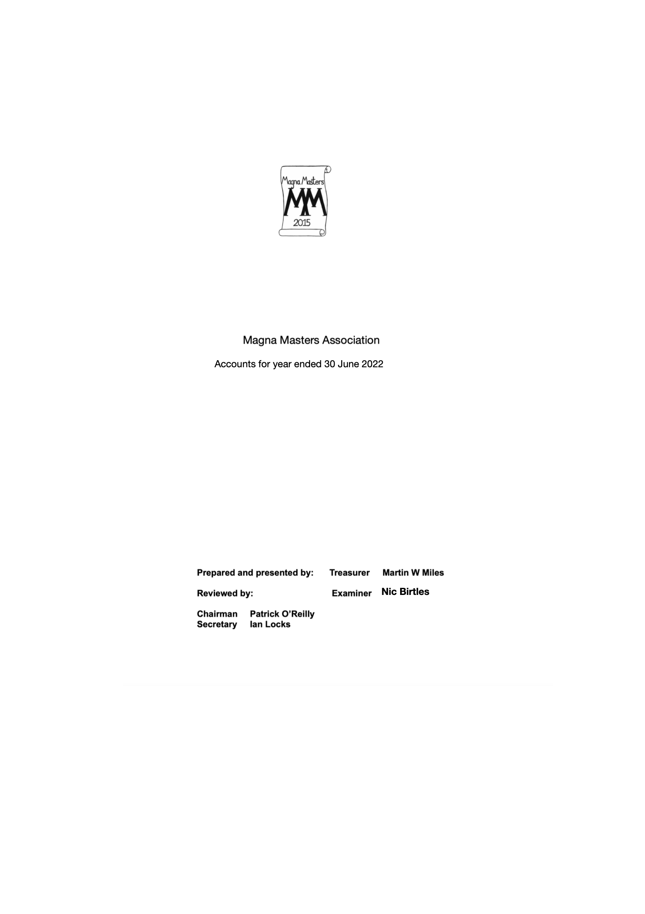
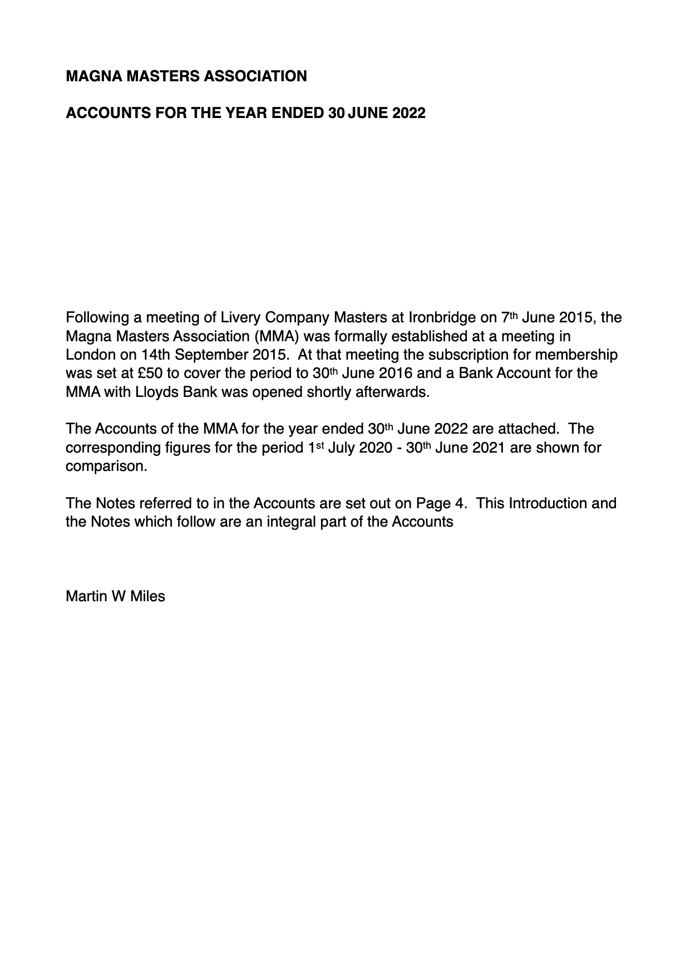
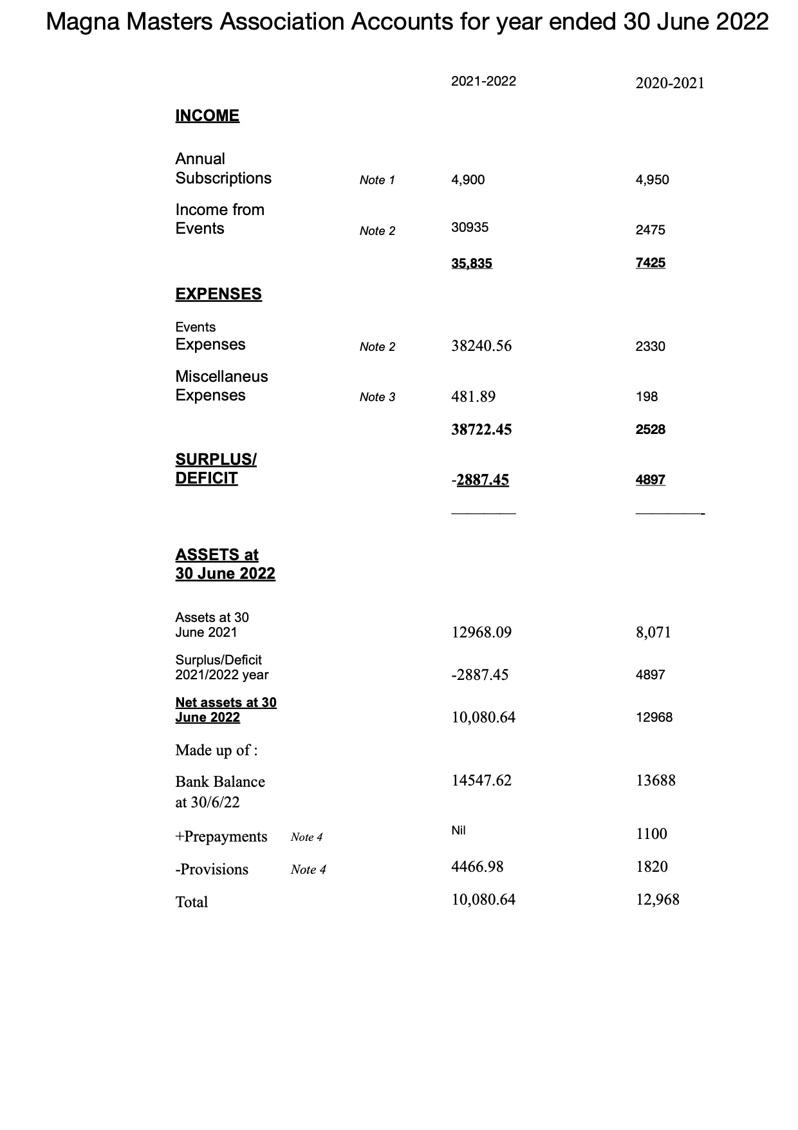
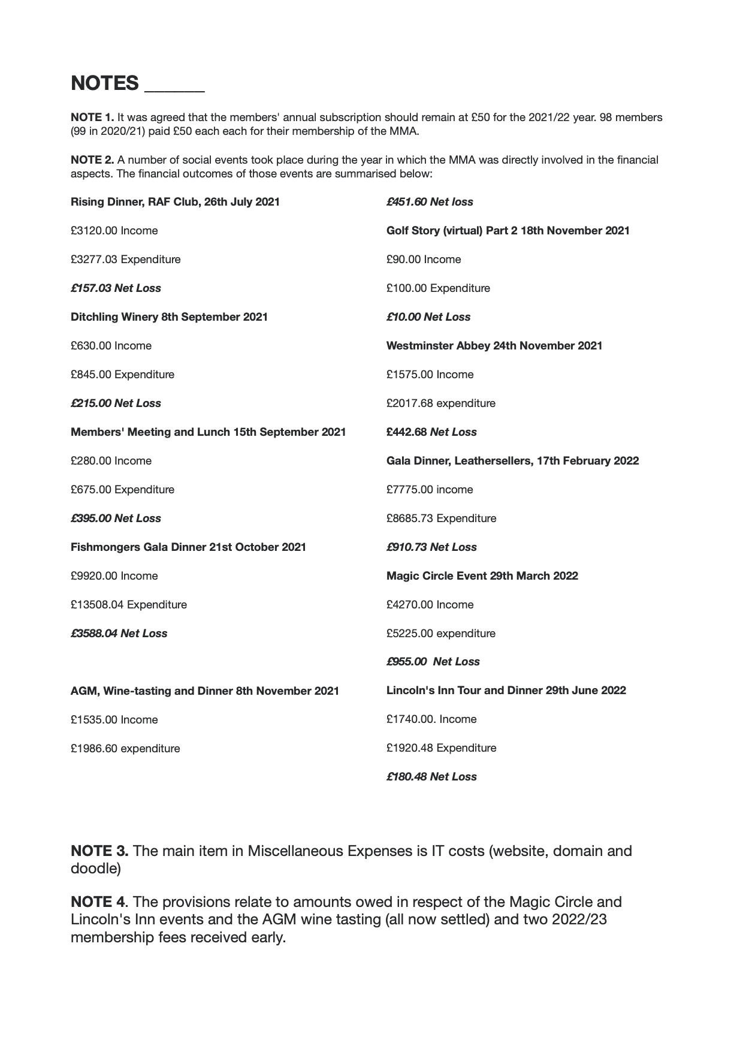
It was suggested that Go Cardless be introduced to assist with the process of ensuring those who booked to attend events committed to doing so by paying at the same time. MM and IL would investigate.

It was pointed out that Consorts attended the AGM the previous year and some would undoubtdely like to continue doing so. It was agreed this be discussed at the Open Committee

The Chairman invited any member with a suggestion for an interesting event to put forward their ideas for inclusion in the programme for the coming or a future year.

Members were invited to make their way to the upstairs bar for a wine tasting organised by Jeremy Randall which would be followed by Dinner.

The Chairman closed the meeting at 18.45

Programme for 2022-23

2022
17 February Seventh Gala Dinner, Leathersellers' Hall
29 March - Evening with the Magic Circle
30 May- 2 June - Visit to Loire wine growing area - Nic Birtles and Jeremy Randall (fully subscribed)
29 June - Dinner Lincoln’s Inn - Tony Watson. This event will be capped at 20 to include Consorts and planned to include a tour of the Great Hall and archives. (Currently fully subscribed)
PENDING
Date tba Visit to Shuttleworth Collection - Jeremy Randall
Winery visits in UK - Allan Cheesman to propose.
2023
Visit to Lake District - Stephen Bernhard and Neville Chamberlain
Golfing events
May - Past Masters Association Spring Golf Cup
Sept - Past Masters Association Pairs Golf Tournament : 4th October at Beaconsfield GC.
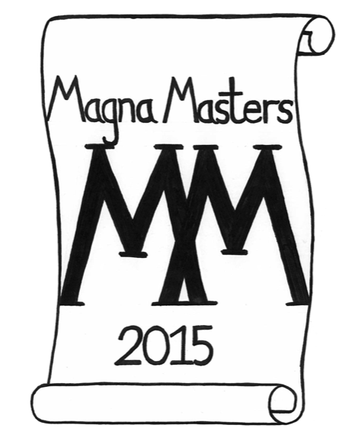
Notes from Open Committee - 5 Sept 22

Notes from Open Committee Meeting 5 September 2022

An Open Committee Meeting of the MagnaMasters was held on Monday 5 September 2022 at Côte St Paul's Brasserie, 26 Ludgate Hill, London EC4M 7DR commencing at 12 noon.

Attending: Anthony Alston, Patrick Chapman, Christopher Ford, Ian Frood, Mark Henderson, Ian Locks, Martin Miles, Roger North, Patrick O’Reilly, John Shonfeld,, Tony Watson, Barrie Stewart, Jim Conybeare, Ian McIntyre, Bob Morrow, Nic Birtles, Derek Woods (17)

Apologies: Peter Williams, Graeme Groom, Graham Dickinson, Richard Herbert, Debby Ounstead, Neville Chamberlain, Stephen Bernhard, Kathleen Duncan, Gwen Rhys

The Chairman paid tribute to David Illingworth, a delightful member of the Association who had sadly died in August after a long illness which he bore so bravely. The Chairman had written to Annie, as had others.

1 Chairman’s welcome and introduction - A summary of the last 12 months and plans for the coming year
- Big thank you to all who have organised events, and also those who supported them, most particularly Ian Locks for his hard work and diligence as our Honorary Secretary.
- In the autumn of last year, we were invited by our President, Sir Alan Yarrow to dine at Fishmongers’ Hall, one of the crown jewels of the City Livery Halls. A delightful evening. Sadly, Sir Alan fell victim to Covid, and Sheriff elect Andrew Marsden stepped in to do the welcome with wit and aplomb.
- Slightly improbably we decided also to go ahead with our February Gala Dinner, kindly hosted by Tony Watson at Leathersellers’ Hall. Numbers at both events were slightly down on our previous expectations but much enjoyed nonetheless
2022
29 March - Evening with the Magic Circle - excellent evening albeit falling rather short of expectations on attendance
30 May- 2 June - Visit to Loire wine growing area - Nic Birtles and Jeremy Randall (fully subscribed and a huge success which, as we will hear, has encouraged us to look to the future with similarly adventurous ideas.) And thank you to Nic Birtles for all his outstanding organization and attention to detail and to Graeme Groom for his excellent photographic record.
29 June - Dinner Lincoln’s Inn - Tony Watson. This event was capped at 20, to include Consorts, and planned to include a tour of the Great Hall and archives.
5 September - Open Committee today: thank you for attending
3 October - Visit to WWII operations bunker at RAFUxbridge organised by Chris Ford who will encourage us to sign up I am sure.
7 November - AGM, wine tasting and dinner, RAF Club, Piccadilly: we are looking for someone take on from Rass the hosting of the wine tasting

There is of course an open Invitation for offers to organise events in the coming year or in the future.

2 Minutes of meeting 9 September 2021 (Link here) “circulated” - can be viewed on website MagnaMasters.com/blog

3 Financial Report (Hon. Treasurer) - Martin Miles, Oral report:

Report by Hon Treasurer. Martin Miles tabled his report which showed a deficit on events. He pointed out this included two Gala Dinners in the one financial year (Fishmongers’ and Leathersellers’ Halls) through Covid disruption however all events had required a subsidy. This had been an extraordinary time and it had been very important to keep our activities going. The Chairman remarked that, despite the distortion imposed by Covid, the finances of the Association were in good shape, and he thanked Martin for his support.

4. Discussion on new Vice Chairman. The Chairman said there had been only one nomination so far: Ian McIntyre proposed in absentia by Richard Herbert. The Chairman said he expected to emulate our first Chairman and keep the Chair for five years, another three on his two so far. Ian McIntyre said he would not expect to do more than two, raising the question of the absence in the Constitution of any guidance for the length of time in office of the Chairman. Ian McIntyre said he was willing for his name to go forward and this was agreed nem con.

5. Upcoming Events - Nic Birtles, chairman of the Events Committee
- In the absence of both Stephen and Neville, Nic Birtles and Ian Locks spoke to the programme in the pack, prepared by Stephen. Notwithstanding the shift by one week in the date, it was hoped that his very special opportunity would be grasped by a sufficient number of members: there is a maximum of 28 attendees.

- Portugal visit 2024 (Nic Birtles) - Nic spoke to a proposal by Grape Escapes which looked like a very interesting and special trip to the Douro in Portugal in May/June 2024. The trip would be open to 10-15 Couples. Other suggestions tabled included:
- Farm and the adjoining Container Port - Dr Ian Frood
- Sabrage evening at the Oriental Club - Bob Morrow
- Two suggestions from Tony Watson: Dinner in the Long Room at Lords; visit to muscular dystrophy research centre

- Visit to WWII command bunker - 3 October 2022 (Chris Ford). Chris said he was only three or four couples short of the 40 people expected for this visit.
- AGM, Wine Tasting and Dinner - Monday 7 November 2022.
- Eighth Gala Dinner at Apothecaries’ Hall - 8 February 2023 (John Moore Gillon). IL said he had met with the caterers at the hall who had come up with what looked like a competitive deal for us enabling us to keep the tick price (just) under £100. It should be a splendid evening.

6. Any other business: IL thanked Patrick Chapman for his help in establishing a new registration and payment system using Ticket Tailor and Strike which had been trialed for this meeting without apparent difficulty. An issue on the availability of a list of attendees was being worked on.

The Chairman thanked those who had attended the meeting for their suggestions and contributions.

